**Worldwide COVID-19 data**

**Group members:**

**Myrna Deseo**

**Archana Karri**

**Neha Sharma**

**Rasika Senadheera**

Project Description

This project explores the publicly available data about covid-19 and the vaccinations globally. Two csv files were downloaded from two different URL's with screenshot below, relevant data were extracted and then joined.

Datasets to be used:

Source - Kaggal

* + worldwide_covid_data

<https://www.kaggle.com/datasets/anandhuh/covid19-in-world-countrieslatest-data?select=worldwide+covid+data.csv>

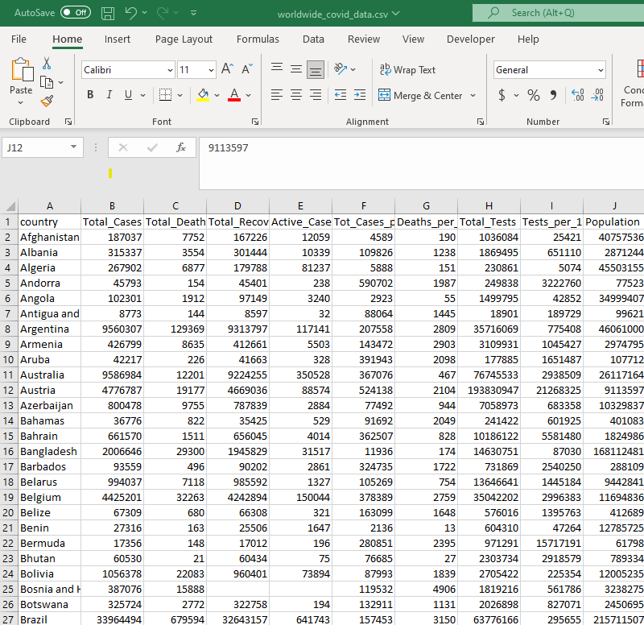

* + country vaccinations

<https://www.kaggle.com/datasets/gpreda/covid-world-vaccination-progress?select=country_vaccinations.csv>

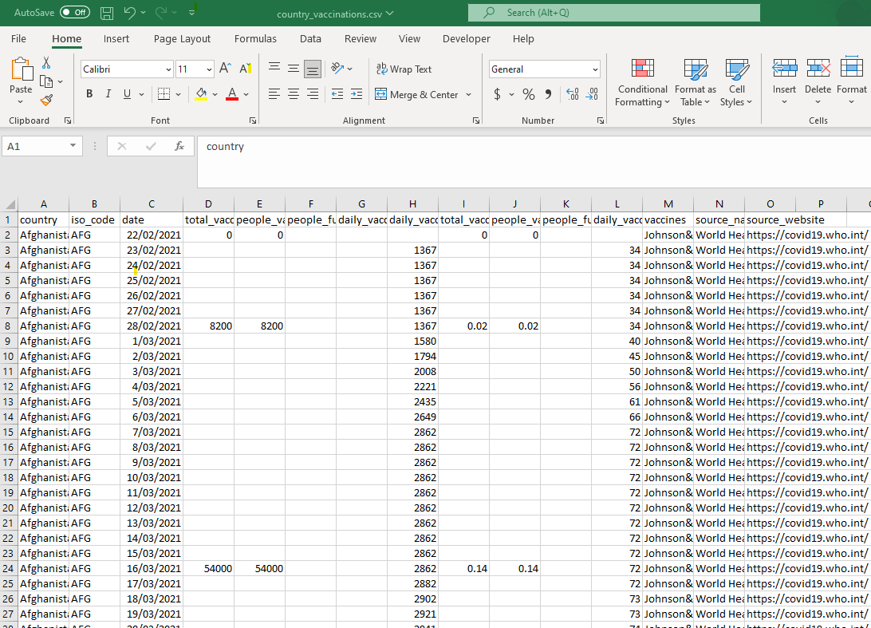

Question to answer:

* *What is the total number of covid-19 cases in each country*
* *What is the extent of mortality (death) for each country relative to its   
  population?*
* *What is the total number of vaccinations for each country?*
* *Can the total vaccination be used as an index to assess the total deaths for each country?*

Breakdown of Tasks:

1. Preprocessing data
2. Extract
3. Transform
4. Load